

**ALAGAPPA COLLEGE OF TECHNOLOGY**

**ANNA UNIVERSITY-600025**

**NM Assignment / Digital Marketing**

| NAME | REG.NO | Naan Mudhalvan ID |
| --- | --- | --- |
| Avantika C S | 2020308003 | 3201E9332893126B0894E5CB72F81BDB |

**ASSIGNMENTS:**

1. Create a blog or website using Blogpost Customize the theme design and post a new article with 500 words.

<https://booksreccom.blogspot.com/2023/10/5-books-to-read-this-fall.html>

2. Create a New Facebook Business Page and post one social media poster for your brand.

<https://www.facebook.com/profile.php?id=61552779965680&is_tour_dismissed=true>

3. Create and design a social media advertisement poster using canva.

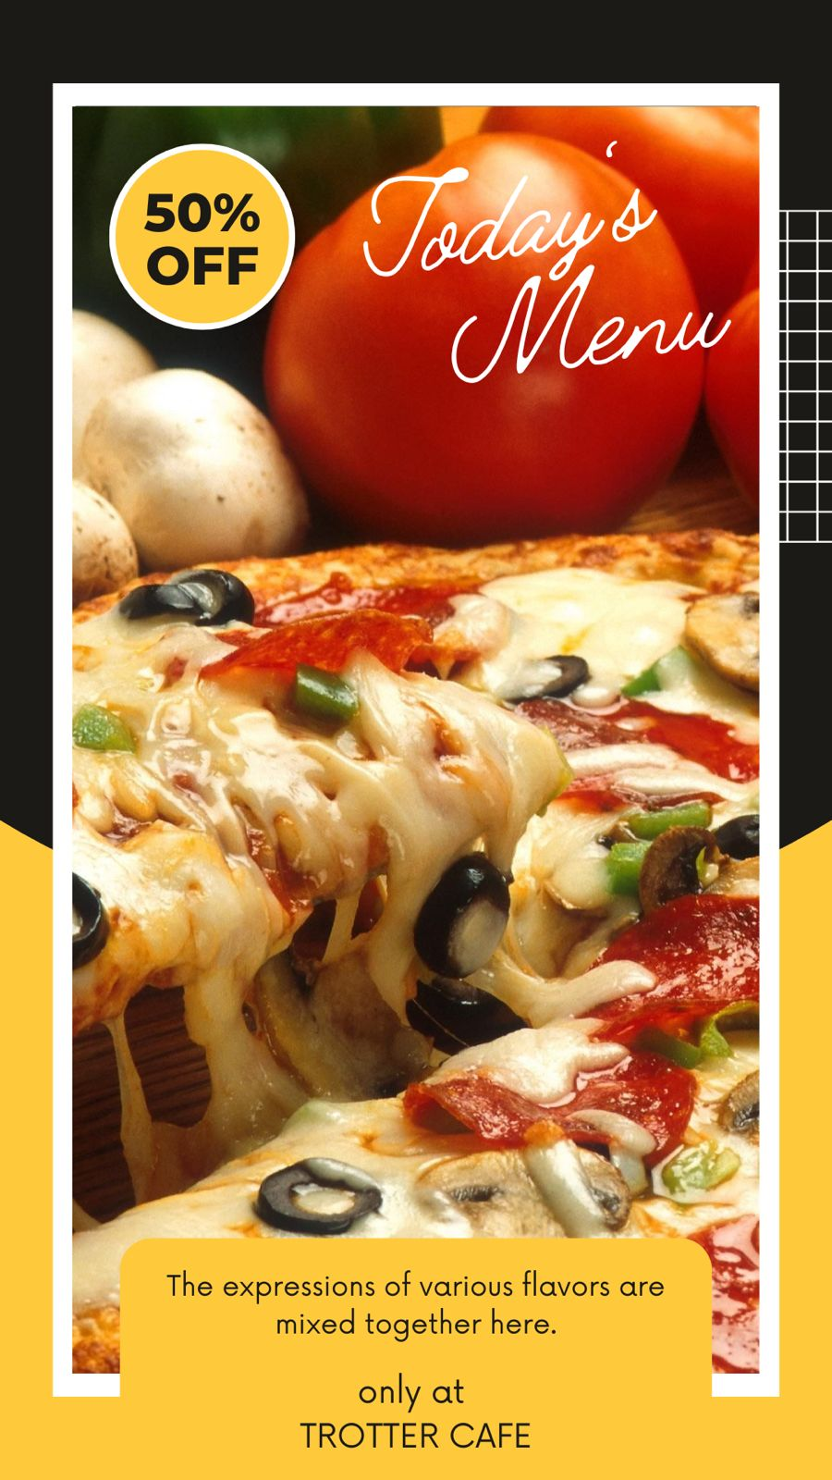

4. Create email newsletter design using MailChimp or canva tool.

